|  |  |  |  |
| --- | --- | --- | --- |
| **SMPcache**  SOFTWARE INTRODUCTION |  |  |  |

**STUDY ON SMPcache**

* **Name:** Phan Văn Bằng
* **Class**: 20IT1
* **Installation**
* Link youtube: <https://youtu.be/GoMyyPFbCVE>
* Link download: <http://arco.unex.es/smpcache/>
* Link drive file download: <https://drive.google.com/file/d/1Y2CERxuqR_jdh0FSGuFHhLMYgSIS5wdC/view>
* Double click: 
* Double click: 

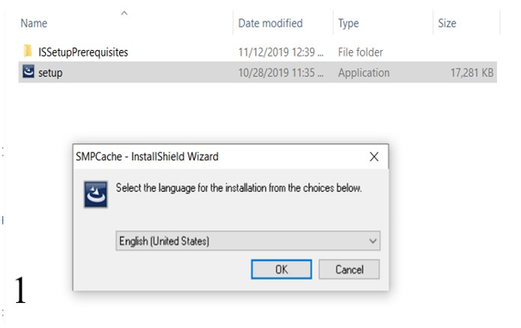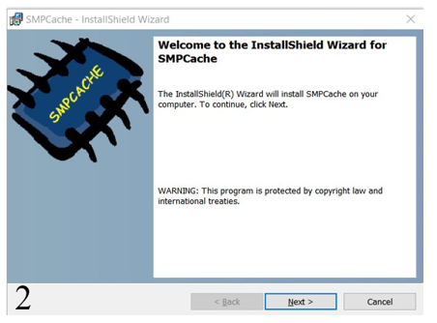

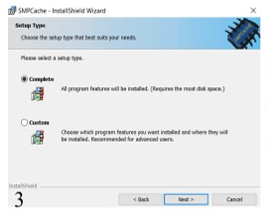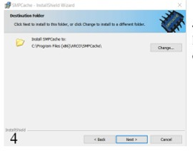

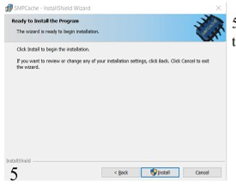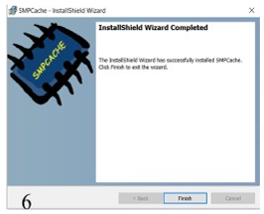

* And double click:

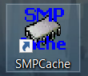

* + GUI

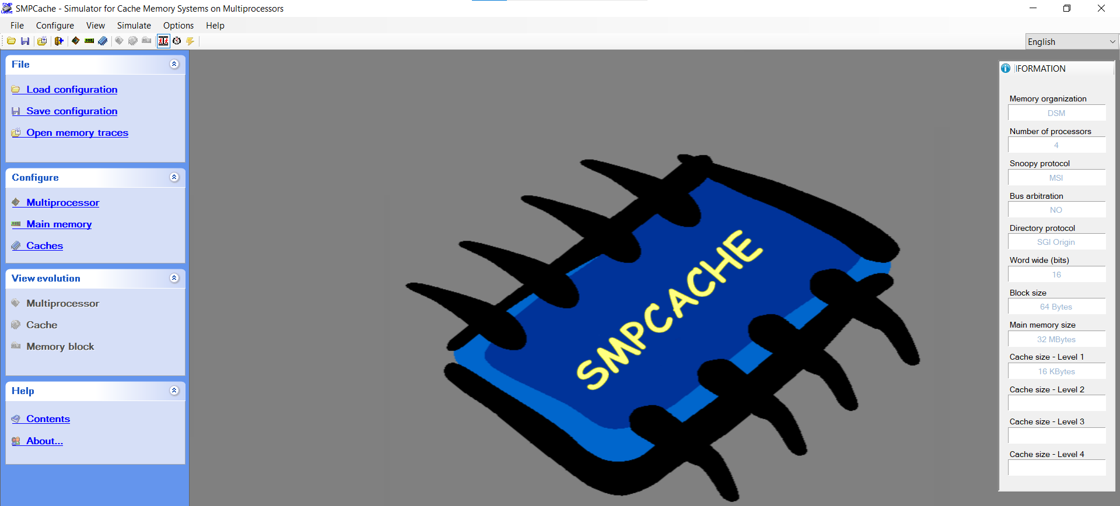

* **Functionality**
* Menu Bar:



* + File Menu

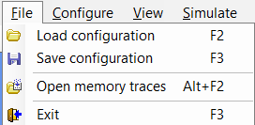

* + Configure Menu

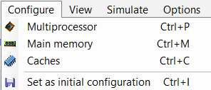

* + View Menu

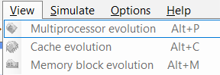

* + Simulate Menu

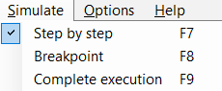

* + Options Menu

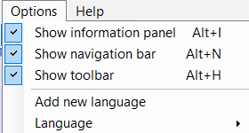

* + Help Menu

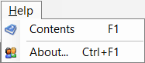

* Tool Bar



* Configuration Panel

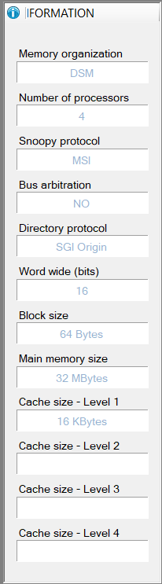

* **Exercise**

**Practice 7:**

* Configure Multiprocessor:
  + - * + Processors in SMP = 8
        + Cache coherence protocol = MESI.
        + Scheme for bus arbitration = Random

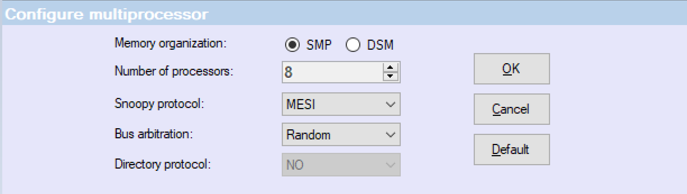

* Configure Main Memory
  + - * + Word wide (bits) = 32 (4 bytes).
        + Words by block = 64
        + Blocks in main memory = 4096
        + Block size = Word wide (bits) x Words by block = 4 x 64 = 256 Bytes
        + Main memory size = Block in main memory x Block size = 4096 x 256 Bytes = 1Mbyte

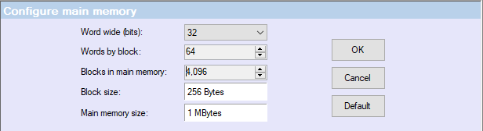

* Configure Caches
* Block in cache = 16
* Cache size = Block in cache x Block size = 16 x 256 Bytes = 4 Kbytes
* Replacement policy: LRU

